<Video games store>

Diagrams

Class Diagram

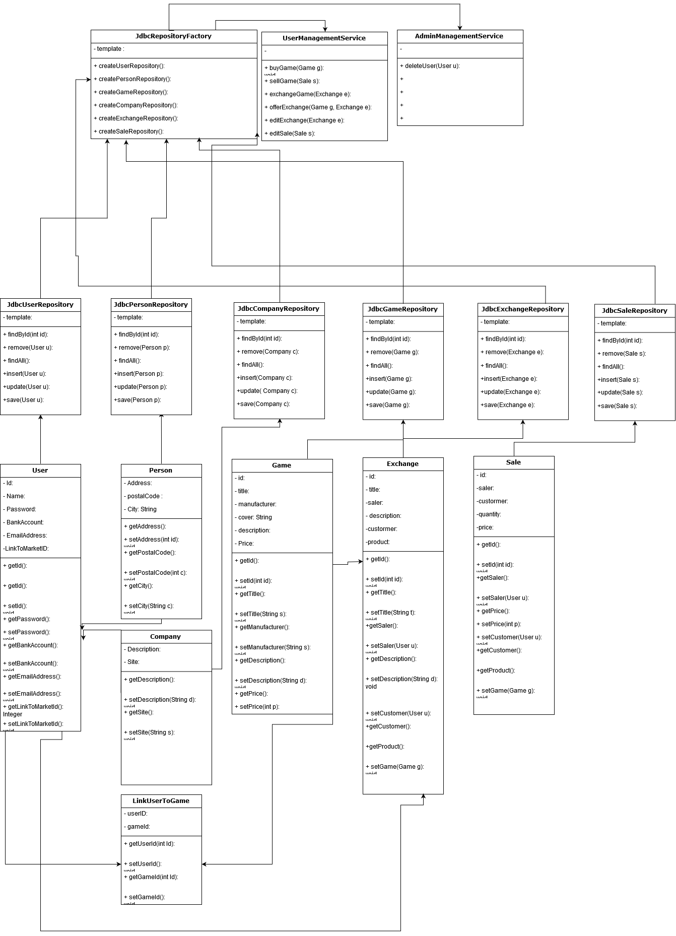

Data Model

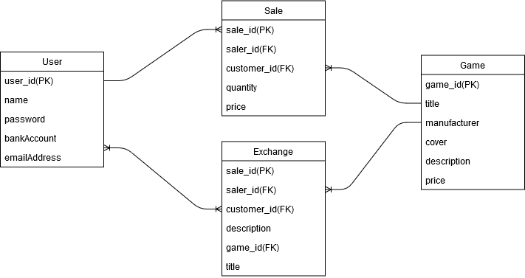

Test Strategy

In order to test the functionalities and validate their correctness, the following tests will be required:

* Log in (user/password not matching/existing)
* Same-time exchange offer ( 2 users offer a game to exchange in the same time)
* Users buy the same game in the same time
* Selling a game that doesn’t exist
* Buying more than it’s on stock
* Database Connection and operations(edit/add/delete)
* Admin rights

Interaction Diagram

